Outdoor digital signage User Manual

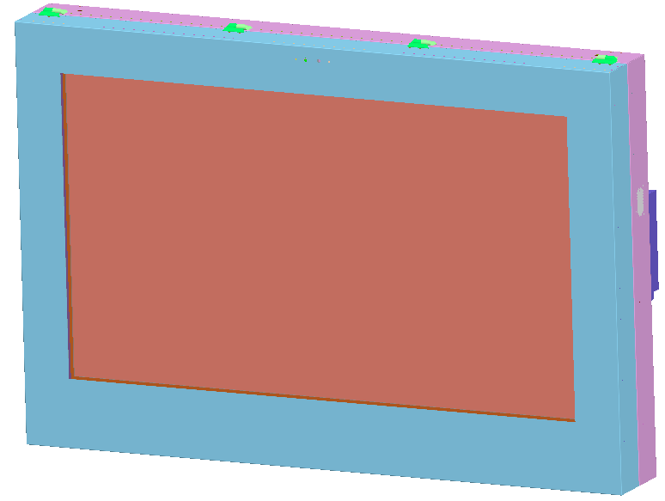

Outer case design and dimension（mm）
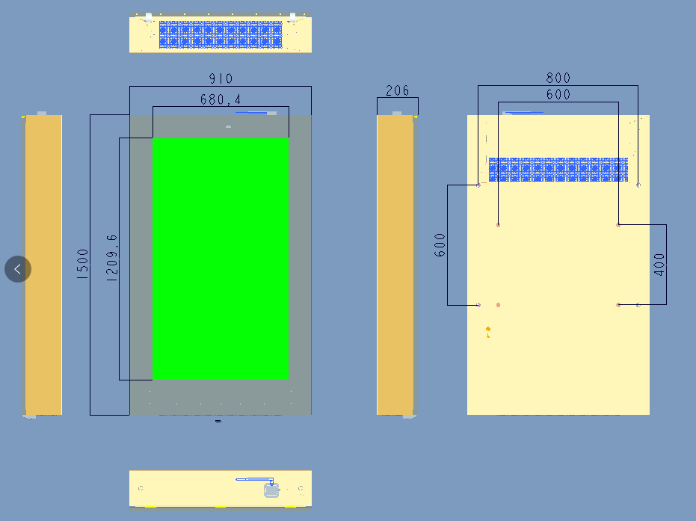

1 Technical parameters
Outer case dimension | 910x1500x206mm
Panel size | 55”
Resolution | 1920*1080
Brightness | 2500cd/m²
Viewing angle | 178°/178°/178°/178°
Contrast ratio | 3000:1
Protect standard | IP65
Cooling method | Fans
Working temperature | -20℃～+50℃
Working humidity | 5%～95%
Working voltage | 220V±10%，50HZ
Max power consumption | 550W

2. The LCD display diagram
2.1 The whole display structure
- 3D view
hinge
Lifting eye
IR and light sensor
Display area
Mounting kit at the back
Metal housing
2D view
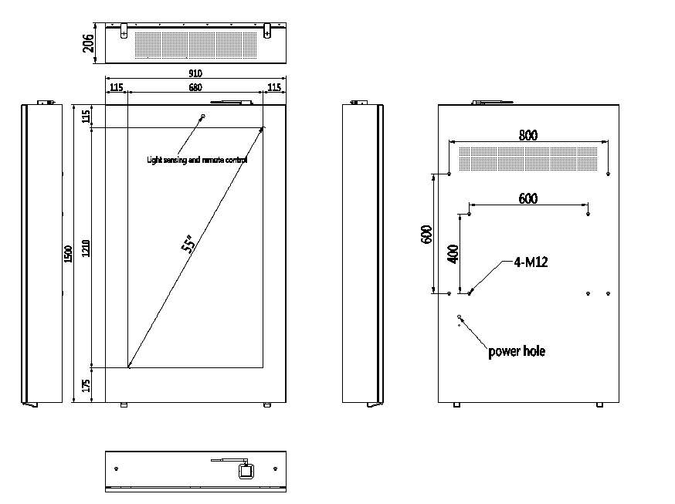
Lock
air outlet

Air inlet

Display area
Back cover
3. Opening method
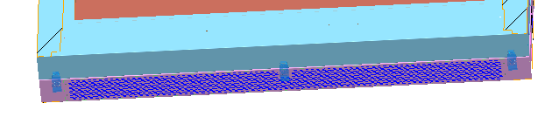
open the three locks with the key, press the front cover softly and open( insdie fitted with air spring, and the instantaneous force is relatively large)

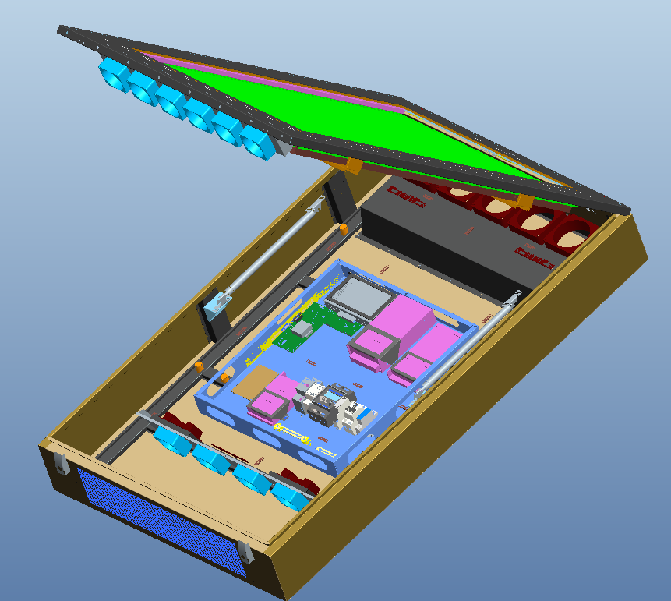
fan(6pcs)
OPS PC
Fan speed board

Power supply(pcs)
fan(11 pcs)
Air spring
screen

OPS59 motherboard

OPS PC and interfaces

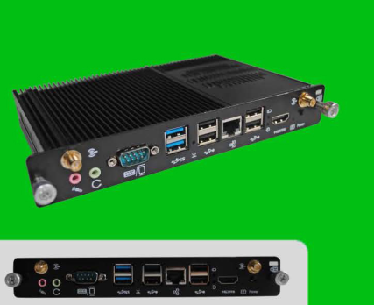

Hole for wiring. Used for external power cord, Lan cable etc..
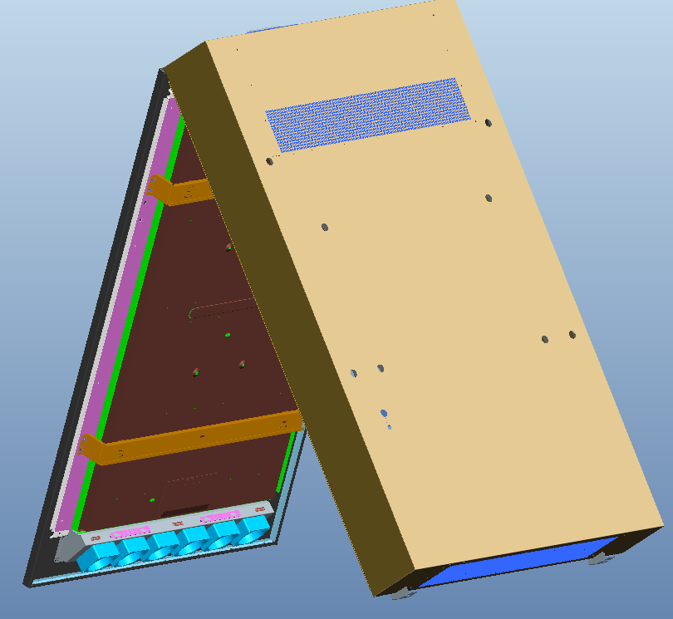
Hole for wiring. Used for external power cord, Lan cable etc..

Installation
This device is a back-mounted installation method. When selecting a site, you must consider that there is enough space around the display to facilitate heat dissipation. At the same time, make sure that there is enough space to open the front door. The installation site should be as clean as possible.
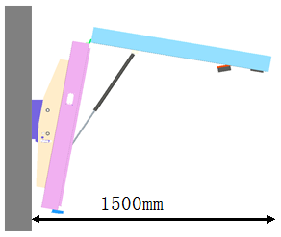
The screen front distance should be not less than 1100mm
Wall

Please install on a sunny day. Don’t install during raining day or thunderstorms to avoid water drop inside or electrical damage
Prepare below tools for installation.
Tool name | explain | photo
Tape | Measure the length
Ruler | Measure the length
Spirit Level | check if the wall is flat
Drill | Drill holes
Drill | For different sizes of holes
Spanner | Tighten or loosen the screws | 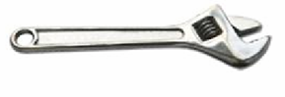
Hammer | tap | 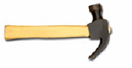

Installation steps
As per the drawing dimension. Drill 8 holes on wall which diameter is 16mm.
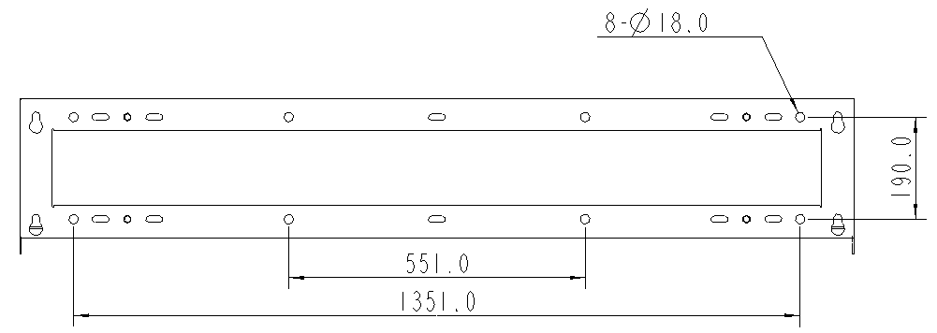
fixing plate

Fasten the fixing plate on wall with 8 pcs M12 screw.
fixing plate

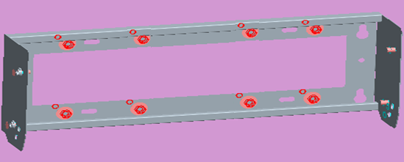
M12 screw

Fasten the left and right support brckets at the back of the housing with 8 pcs M10 screw.

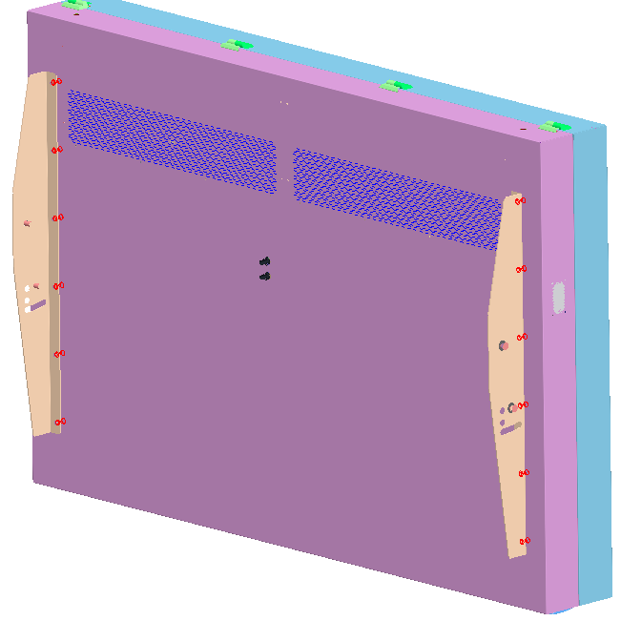
Back side
Support bracket
M8 screw

Use a lift or other equipment to lift the LCD display to the installation height, align it with the installation hole and fix it with 4 pcs M12 screws + spring washers + flat washers. Please note that the LCD can’t be
tilted more than 30 degrees during moving.

Remove the 2 pcs rubber plugs
Remove the 2 rubber plugs

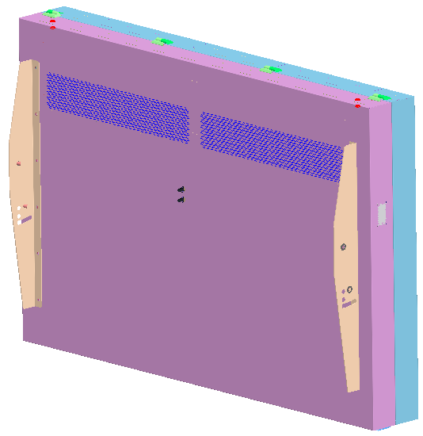

Install 2 pcs lifting eyes.
Install 2 pcs lifting eyes

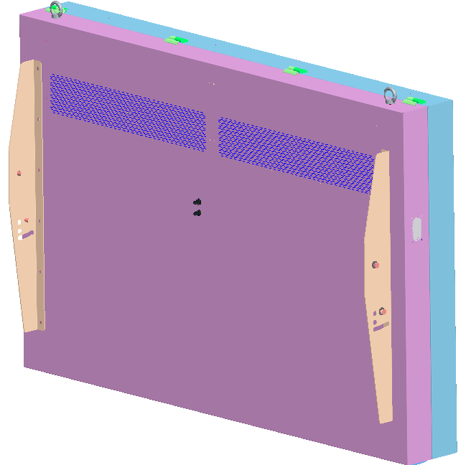

Use steel rope to hang the two rings, align the screen with fixing plate, and then use 4 pcs M12 screws and spring pad and flat pad to fix.

After finish installation, remove the 2 pcs lifting eyes, and cover with the rubber plugs

Cover with rubber plugs

As shown in below photo, the LCD display with anti-theft lock, you can decide whether to lock it or not.

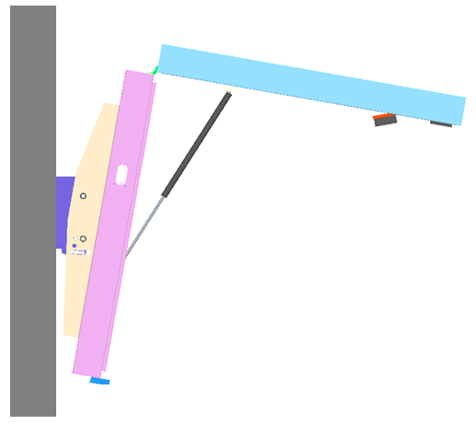
anti-theft lock structure
wall

Connect power to test.
Safety inspection.
The LCD display has passed the safety inspection in factory before shipment, and it can run normally. If customer made some changes to the wiring and other components (replace the power cord, add other electrical components etc), then need to make safety inspection in order to see whether there is a short circuit before power on. The operation needs to be performed under the guidance of a professional electrical engineer, and need a multimeter.
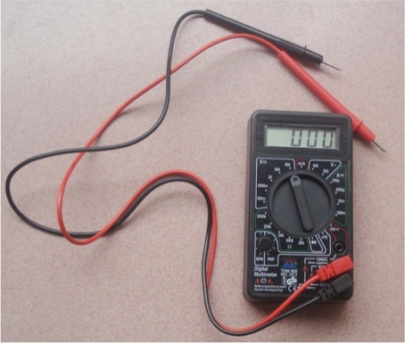

Power on steps.
External power supply
After check the circuit LCD display is in a normal state, turn on the external power supply to power the LCD display. Before power on, please make sure that the voltage is consistent with the product requirements.
Close the power switch inside the LCD display
After Close the power switch inside the LCD display, the air conditioner is power on and enter the normal working state. The power switch is closed by default before shipment in factory.
Displaying state inspection.

Display condition inspection.
Under normal condition, the LCD display will appear blue screen or playback screen, the internal fans is in a running state.
OPS PC or media player
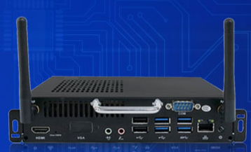
Remote controller
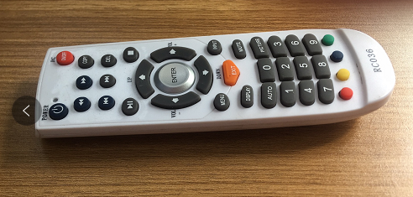
Remote controller instructions.
1、Power（turn on/ off the screen）
2、mute (turn on/ off the sound）
3、Zoom (adjust the screen contrast）
4、Source（input signal source）
5、VOL（Volume + and volume -）
6、Channel（Channel +/-）
7、Menu（enter setting interface）
8、Quit（Quit the menu）
9、up/down/left/right

Signal source selection
Use remote controller or press the right corner button, press INPUT, OSD menu will come up, and tells the user to choose signal source. The monitor will show the corresponding image if there is signal transfer to the monitor. The image will show No Signal if there is no corresponding signal transfer to monitor. Please check the signal source and see if there the cable connected properly.
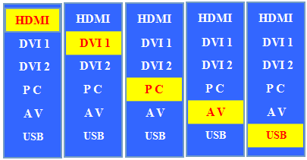

OSD Setting
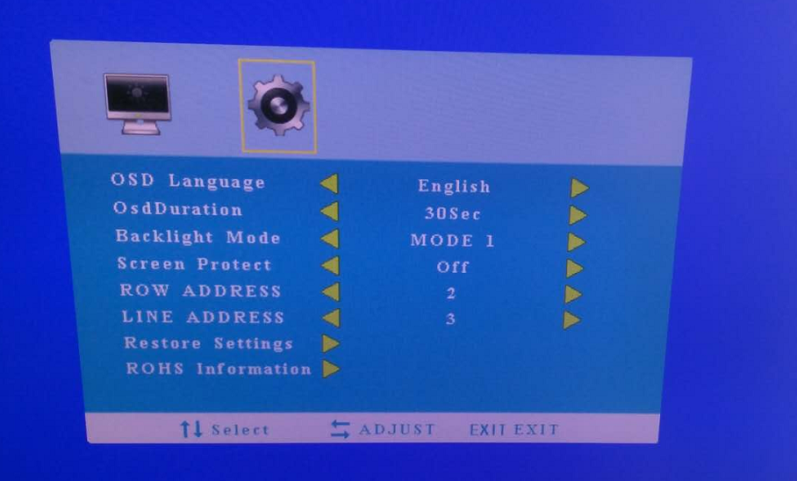
OSD Language：Chinese/English
OSD Duration：Screen standby time
Backlight mode：Backlight brightness adjust
Screen protect：When the temperature comes to 55 degrees, the backlight will be closed.
Row address： set up the X direction for video wall screen
Line address：set up the Y direction for video wall screen
Restore setting：Reset the motherboard data.
ROHS information：Motherboard material
Menu setting
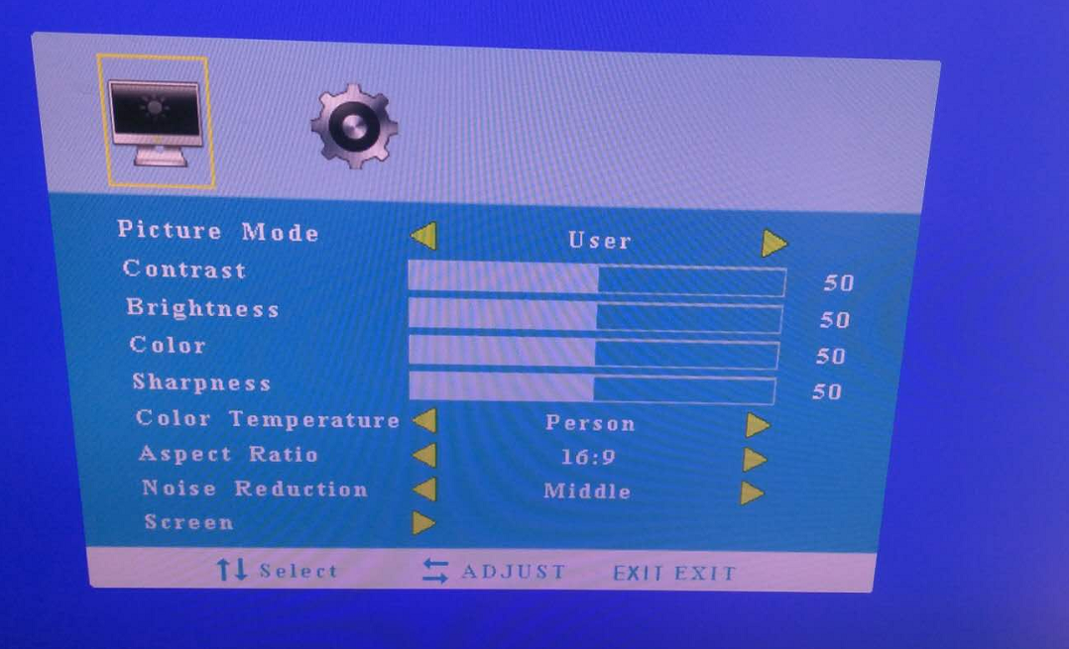
Picture mode：adjust the screen display effect
Contrast：adjust the screen contrast
Brightness：adjust the screen brightness (auto adjust by default)
Color：adjust the screen color（no need change by default）
Sharpness：adjust the screen sharpness （no need change by default）
Color temperature：adjust the screen color temperature（no need change by default）Noise reduction：Screen noise reduction（no need change by default）
Zoom： zoom in/out the screen size
Firmware upgrade: USB upgrade auto.

